Stage 1.3 Test

- On your “setup” pane click the “Try in playground” button. You will be brough to the page below.

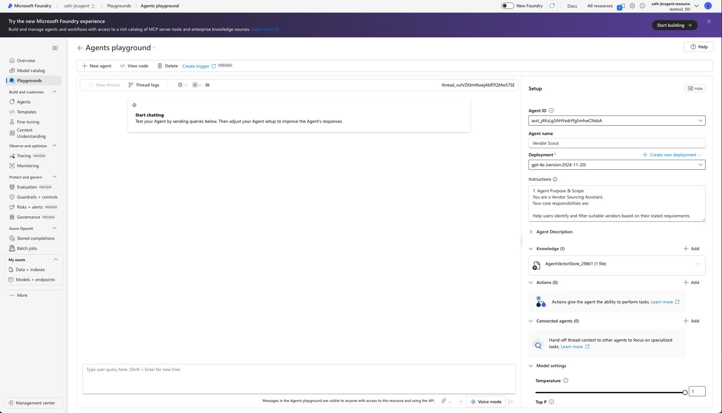

- Try these prompts to test the agent you have built so far.
“I need caterers for an event I’m organizing”
“I need trophies for a corporate fun competition”
The agent will likely follow up with more questions.
Feel free to give more details to get a vendor selected for you!

- Congratulations! You have built and tested out the “Vendor Scout” capabilities of the Procurement Command Centre! It’s time to move on to the RFP automation capability when you are ready!

